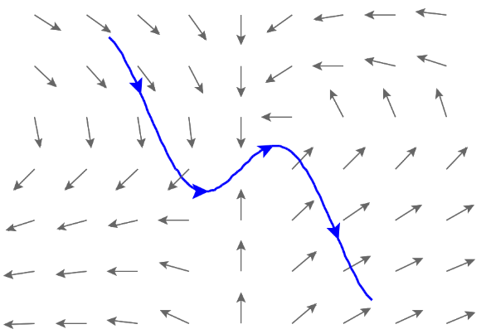
5.2.2 Work Integrals

Motivation: Suppose, as in the last section, we have a curve C that we are interested in travelling along, but we are now wanting to move along this curve through a vector field.

In the last section we saw that a line integral was useful for “adding up” a quantity as we progressed along a path. In this section we are interested in the vector field’s effect on the motion of an object along the curve C, specifically in regards to the amount of work done by the vector field on any object that traverses C.

When the vector field is moving with the direction of the curve it contributes positive work in the motion of an object along the curve. When the vector field is moving against the direction of the curve it contributes negative work in the motion of an object along the curve.

Exploration: Suppose that is a continuous vector field. Suppose also that models some force field in space (for example F could represent a gravitational field or an electric force field).

Suppose a particle moves through this force field along a smooth curve C which is given by the parameterization where . Suppose that the particle starts its movement at the point and ends its movement at the point . We want to know the amount of work done by F on the particle as it moves from to .

This problem is particularly complicated because the force is continuously changing as the particle moves through space. So, we start by trying to approximate the force in hopes of being able to relate our approximation to an integral.

To do this we partition into n equally spaced intervals. This inherently partitions the curve C with n + 1 points. A picture is below:

We let represent the length of the segment from to (the segment approximates C from to ).

We let be some sample point in , and suppose that .

We approximate the work done by F on the particle as the particle moves from to as follows. As long as and are close together, the force is approximately throughout the movement from to .
Moreover, as long as and are close together, the motion of the particle is approximately in the direction of the unit tangent vector T to the curve at any point between and , and the distance the particle travels from to is approximately .

So, by the way work is defined, the work done by F on the particle as the particle moves from to is approximately:
.

Thus, the total work done by the force F in moving the particle along C is:

We know that , and from chapter 2 we know that .
So, we have:
.

Definition: Let F be a continuous vector field defined on a smooth curve C given by a vector function where . Then, the line integral of F along C is

Note: We will address an intuitive meaning of dr in the next example. One should note that F may have any number of components and the above definition will still apply.

Example 1: Find the work done by the force field in moving a particle along the line segment, C, from to . (Notice this is the same as Ex 5 in section 5.2.1!)
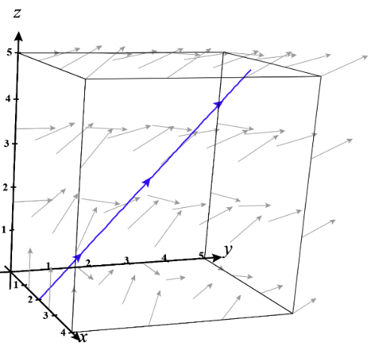
Using techniques from Chapter 2 we note that a parameterization for C is where . We know that the work is equal to the line integral of F along C.

So, by the above definition we have that

Observation:
We can view our resulting work integral as .
If we think of , we see that .
So, thinking of as gives us a way to interpret the first part of the above definition, and we now see that line integrals with respect to x, y, and z do indeed show up when we need to find work!

Note: One may recognize as the sum of line integrals we found for the last example in the previous section.

Example 2: Find the work done by on a particle which moves along the curve C given by where .
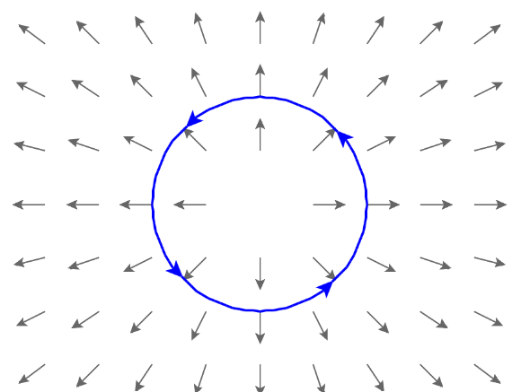
We know that the work is
.
We note that parametric equations for the curve are .
These imply that and .
Thus, we have that .

Note: One should draw a picture of the particle’s path and this vector field to see why the work is equal to 0.
When this is done you can see that the at all points the vector field is orthogonal to the curve C and therefore at all points. This means that .

Note: One could have solved the above problem with as well and gotten a result as follows.

